Report of Assessment 2

Jiancheng Zhang H00341619

**1. Overview:**

**1.1 Technical section:**

I create gunfighter, knight, and racer as subclasses and Competitor as super class. The overall score within three subclasses are all ranked by value, the greatest one is rank 1. 5 competitors in gunfighter, 4 competitors in knight, and 5 competitors in racer.

CompetitorGUI contains all GUI components that I used. There are three panels I used which are north panel, center panel, and east panel.

In north panel, I used GridBagLayout class to arrange layout, because there are different JTextArea and a JButton.

In center panel, there are three kinds of competitors, and each kind of competitor can sort in different ways. The JScrollPane is used to display the list after sorted, and the vertical scrollbar is always showing while the horizontal scroll bar shows only needed. To gunfighter, I used JButton to receive an order. To knight, I used JRadioButton to receive the order. To racer, I used Choice to receive an order. In search panel, there are three JTextArea and a JButton. All of these panel is placed into listPanel use GridLayout and put on center of the frame.

In east panel, there are several JCheckBox and can show a list of all competitors by filter different levels. There is a close button that will create a new frame that needs the user to enter a name output file. The Choice and JCheckBox is used itemStateChanged method to listen, rest of JButton is used actionPerformed method to listen.

**Alter scores function**: first enter competitor number and an array of scores, then click alter button. actionPerformed() method and alterScores() will be used. In alterScores(), if there is no error in input, alterScores() of CompetitorList class will be used and return an overall score of that competitor.

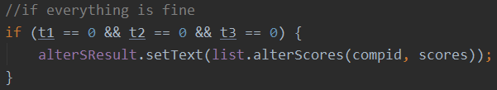

If there are errors, different error messages will be displayed in the text area.

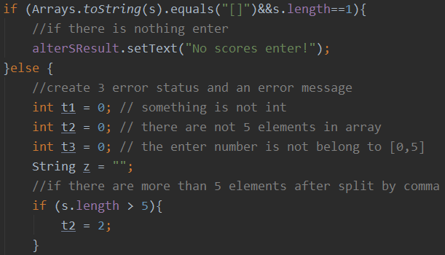

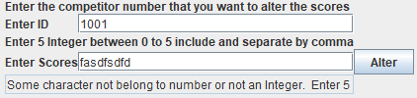

Exception scenario

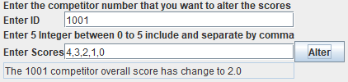

Normal scenario

**Sort list function**: there are three kinds of way to list, when select list by name or overall score, actionPerformed() or itemStateChanged() method will be used, then sortCompetitor() method in CompetitorList will be used, if list by age, compare() method in AgeComparator class and sortCompetitorAge() method in CompetitorList class will be used. A list of certain competitors will be displayed in text area.

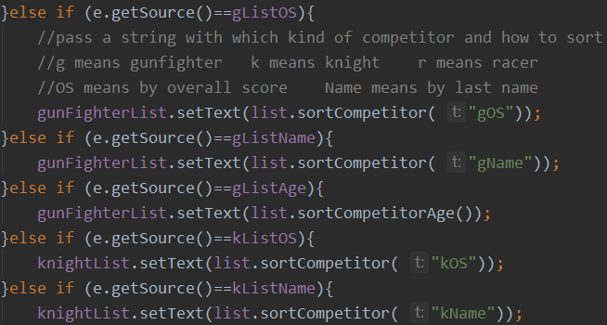

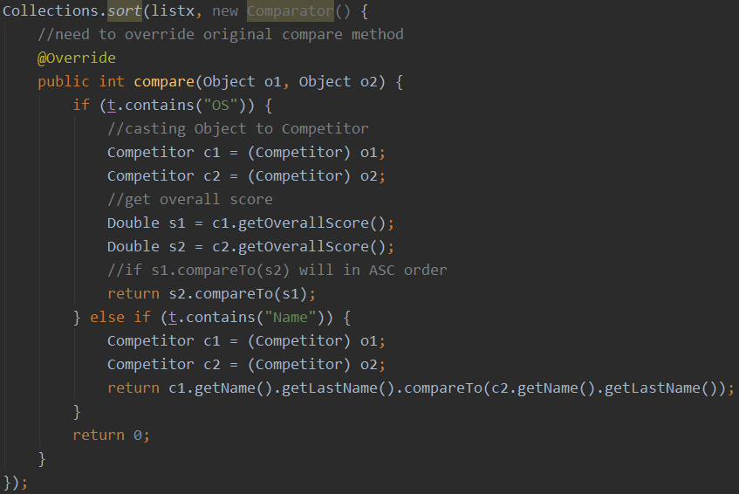

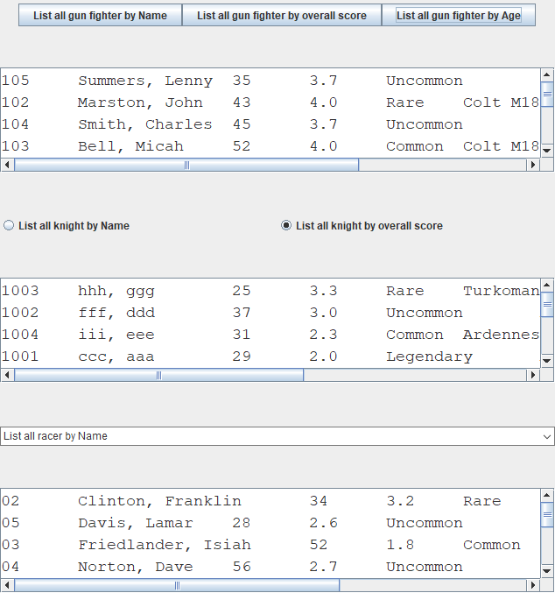

Normal scenario

**Search competitor function**: after enter an ID and click search button, actionPerformed() method and searchCompetitor() method in CompetitorList class will be used. If the program finds the competitor that the user is looking for, a short detail will be displayed. If not, there is an error message in text area.

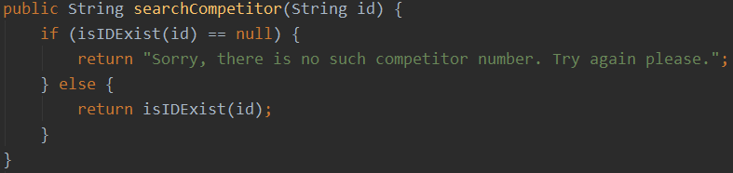

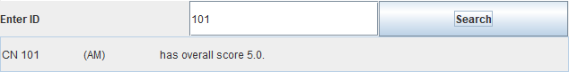

Normal scenario

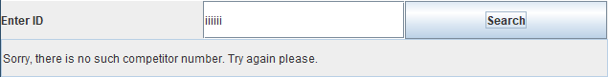

Exception scenario

**Filter function**: after user single or multi choice, itemStateChanged() and alterCom() method will be used. A list of all competitors with choose level will be displayed.

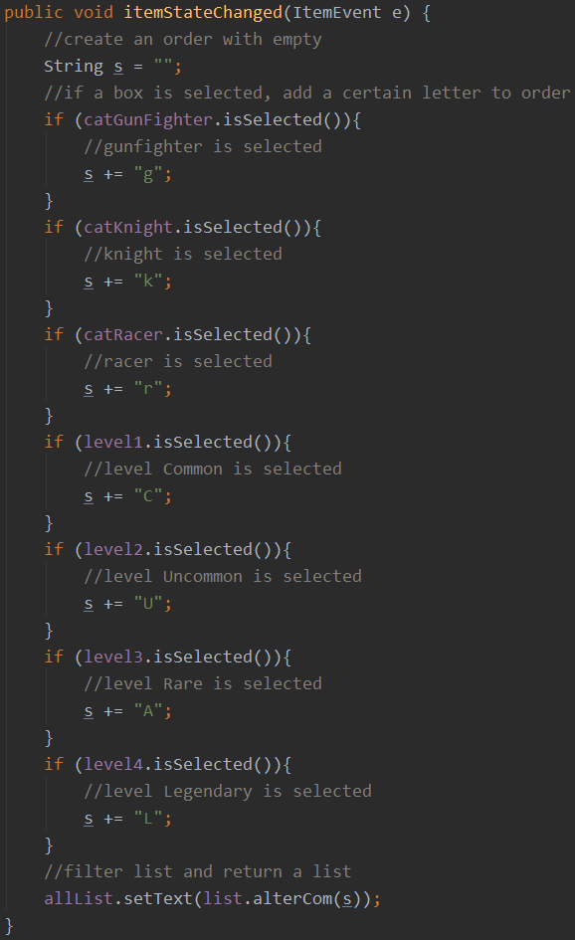

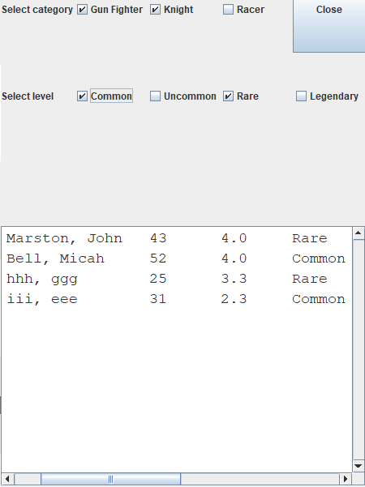

Normal scenario

**Click exit button of the main frame**: windowClosing() method will be used and create a JOptionPane.

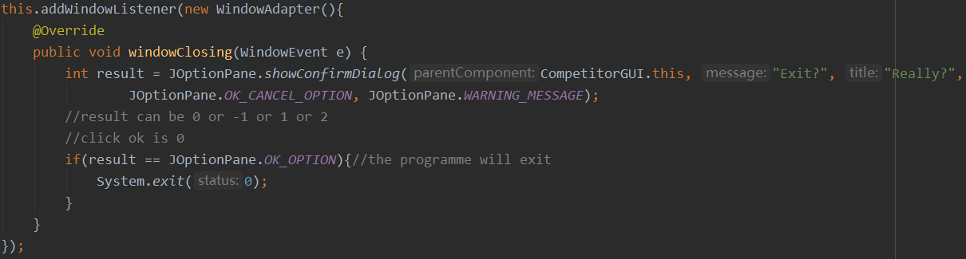

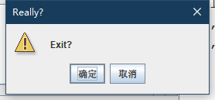

Normal scenario (OS language is Chinese, so the button is in Chinese)

**Click close button**: newFrame() method will be used.

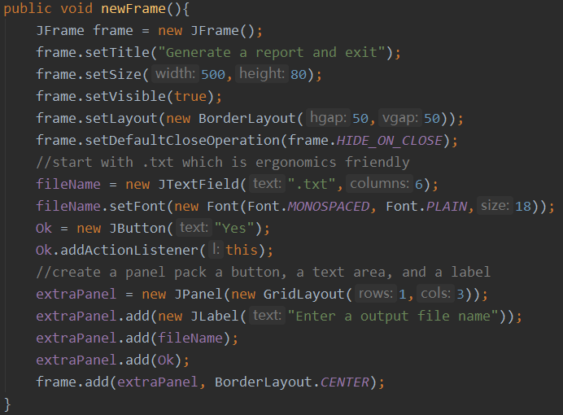

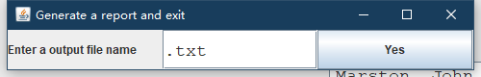

Normal scenario

**Output a report**: user enters a name of a file and click yes, output() method in FileIO class will be used, a new file is generated and program terminate. If you want to over write the input files, "Access denied." will be displayed in terminal.

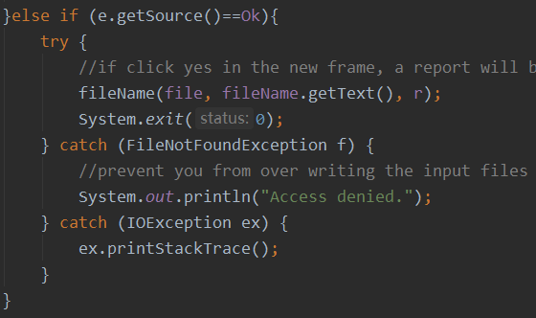

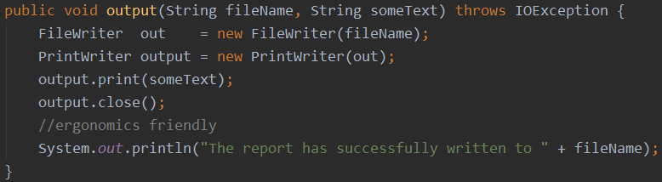

**1.2 Status section:**

This application meets the specification fully.

There are no known bugs.

|  |  |
| --- | --- |
| Problem | Effect |
| When altering scores, if it cannot find a competitor that the user entered. E.g. 1111 | An error message will be displayed which "There no such competitor in the list! Try again.". |
| User enter non-numeric score or Double in GUI. E.g. aaaa | An error message will be displayed which "Some character does not belong to a number or not an Integer.”. |
| User enter scores less than 0 or greater than 5. E.g. -1,9,3,2,3 | An error message will be displayed which "Each score need to belong [0,5].". |
| User enter the number of scores less or greater than 5. E.g. 1,1,1,1,1,1,1 | An error message will be displayed which “Enter 5 number please.”. |
| User enter nothing in scores. E.g. “” | An error message will be displayed that "No scores enter!". |
| When finding short detail by entering competitor number, if it cannot find a competitor that the user entered. E.g. 1111 | An error message will be displayed that "Sorry, there is no such competitor number. Try again please.". |
| When entering the output file name, if that file is input file or read-only. E.g. GunFighter_list.txt | An error message will be displayed that "Access denied.". |
| When IOException occurred. | The exception message will be displayed. |

**2. Diagrams:**

**2.1 Use case diagram:**

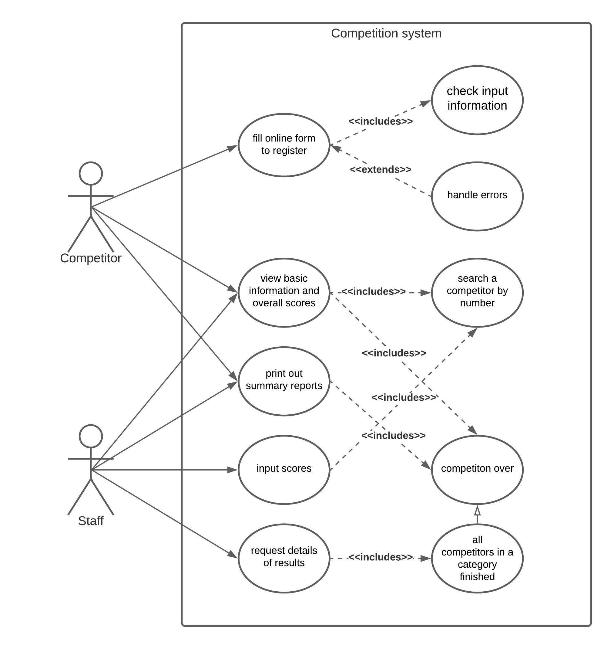

**2.2 Textual description:**

USE CASE: Registration

GOAL: To get a qualification for the competition

ACTORS: Competitors, System

Main success scenario:

1. Competitors enter name

2. Competitors enter email

3. Competitors enter date of birth

4. Competitors enter category

5. Competitors enter level

6. return a unique competitor number and accept registration

Alternatives:

1a, 2a, 3a, 4a, 5a. any of them are omitted --- display an error message and refill them

2b. there is a same email address already exists in a same category --- reject the registration and start again at (2)

2c. there is a same email address already exists in a different category --- the registration accepts and allocate a different competitor number from the previous competitor who has same email address

3b. a competitor’s age doesn’t match level --- start again at (5)

**2.3 Activity diagram:**

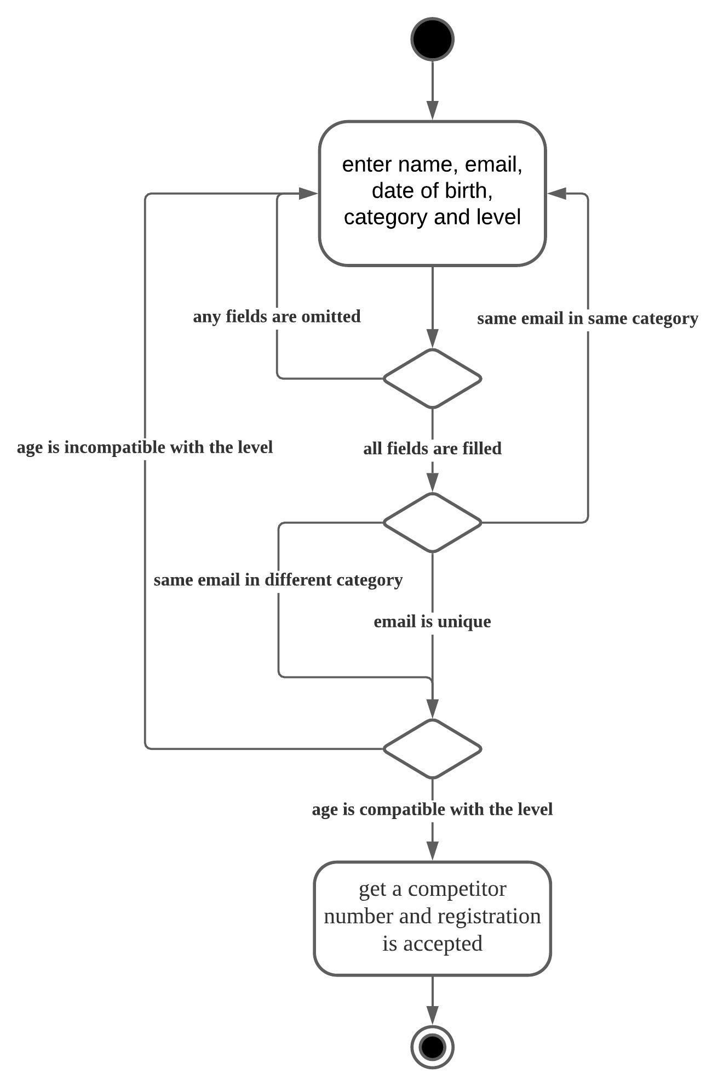

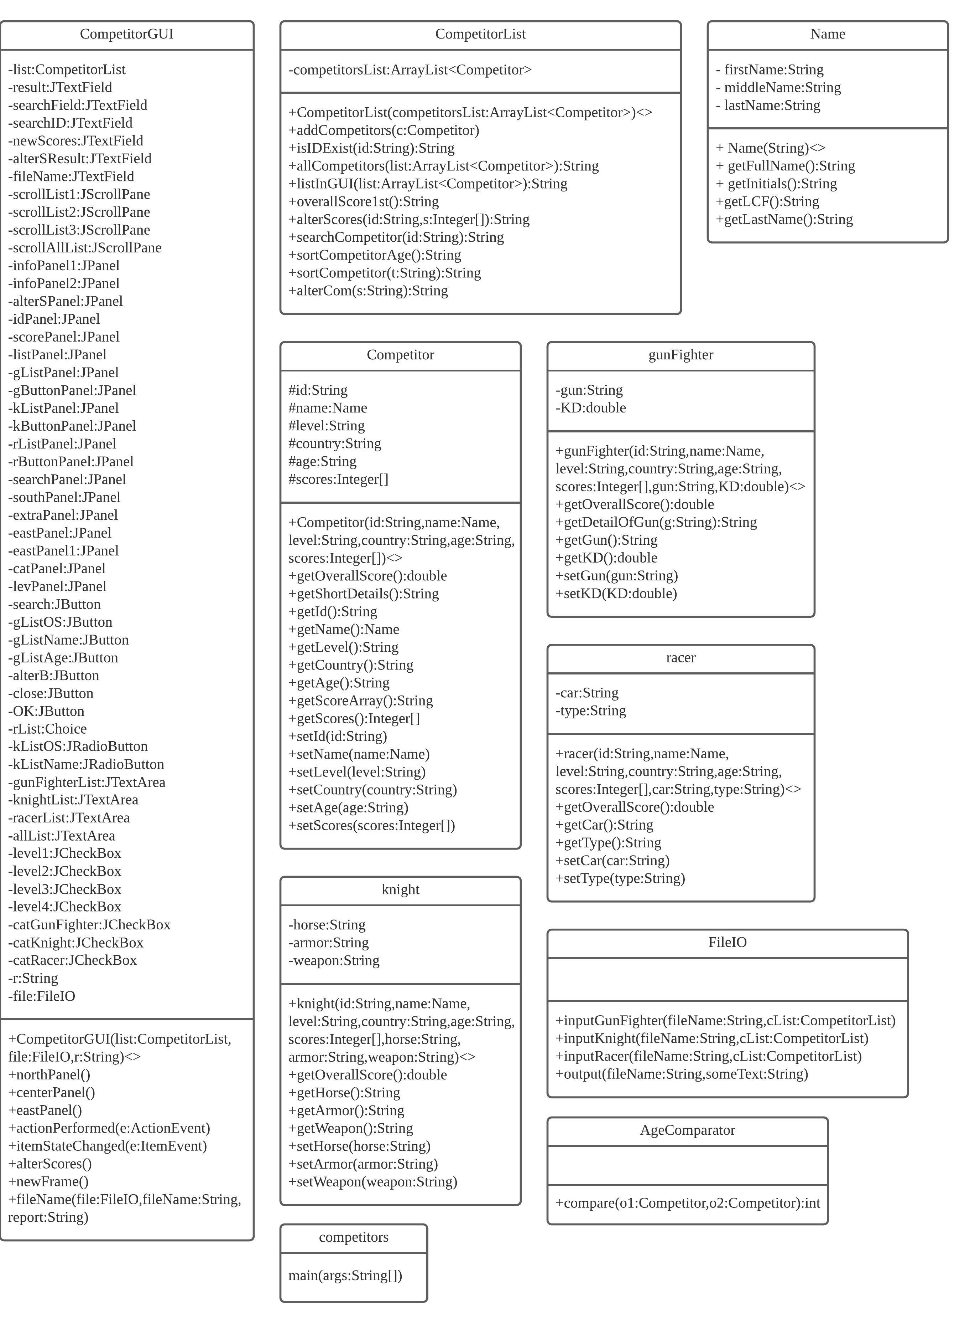**2.4 Class diagram:**

